Transferring Trade Paperback Expanded Distribution from CreateSpace to IngramSpark

Overview
The following outline offers step-by-step instructions and troubleshooting tips for transferring paperback titles currently uploaded at CreateSpace and offered for expanded distribution with a publisher-owned ISBN* to IngramSpark.

*Any books uploaded at CreateSpace with a CreateSpace-issued ISBN cannot be transferred to IngramSpark. Those titles should transfer to the KDP interface in due course.

A little about how and why this process works… Books that are distributed from CreateSpace to bookstores and online retailers via expanded distribution are sent through Ingram as part of that distribution. (https://www.createspace.com/Products/Book/ExpandedDistribution.jsp) Once your book has become part of Ingram’s distribution database, Ingram can work with you to request and transfer that title be released from CreateSpace and moved to your IngramSpark dashboard. The book transfers with the same ISBN, interior and cover, binding size, page count, paper style, etc.

Disclaimer
The following outline is based on recent experience (summer 2018) successfully transferring numerous titles for multiple author/publishers. As Amazon rolls out its own process of transferring distribution from CreateSpace to the KDP dashboards, I cannot guarantee these instructions will continue to work. Also, distribution is a publisher choice, and each publisher should research to see whether distributing through IngramSpark is a good choice for her/his business model.

Preparing for the Transfer Process

1. Create an IngramSpark account: https://myaccount.ingramspark.com (gold button, lower right). Be sure to complete all the account setup tasks.

2. Visit your CreateSpace dashboard https://www.createspace.com and make a list of all titles and ISBNs that you want to transfer to IngramSpark. If you have a lot of titles uploaded at CS, you may need to go to the bottom of the Member Dashboard screen and look for the button to View All Titles. That brings up a screen with all of your titles on it.

To gather the ISBN and confirm the title will qualify for transfer, you need to click on each title from the Member Dashboard screen and visit each book’s Project Homepage.

Start a list, and include the following for each book you want to transfer:
ISBN (13-digit version)
Title
List Price
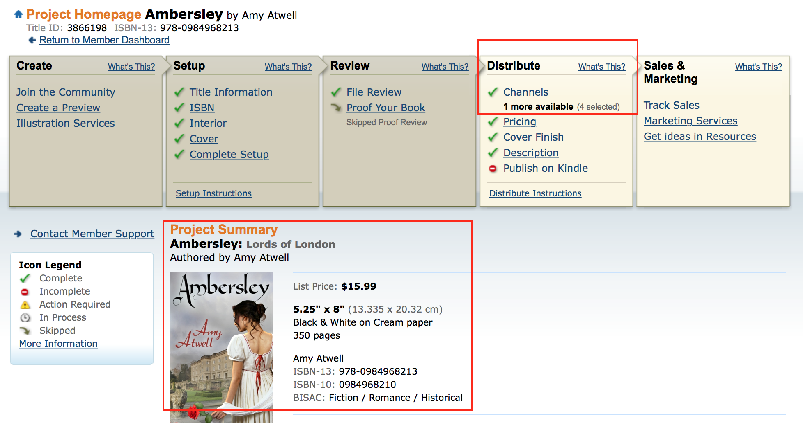

3. Confirm the title is activated for Expanded Distribution. From the Project Homepage above, click on Channels on the Distribute menu. On the Distribution screen below, confirm that the Bookstores and Online Retailers option is selected. If it’s NOT selected and you’re sure this is a title you want to distribute to IngramSpark, you can Select and click Save at the bottom. You will want to wait about a week before requesting the transfer, to allow time for the book to feed into the Ingram computer system.
Note: Books that have Publisher-assigned ISBNs will show the Library Distribution as not eligible. If the Library Distribution option is active, then you have a CreateSpace-issued ISBN, and this title cannot be transferred.

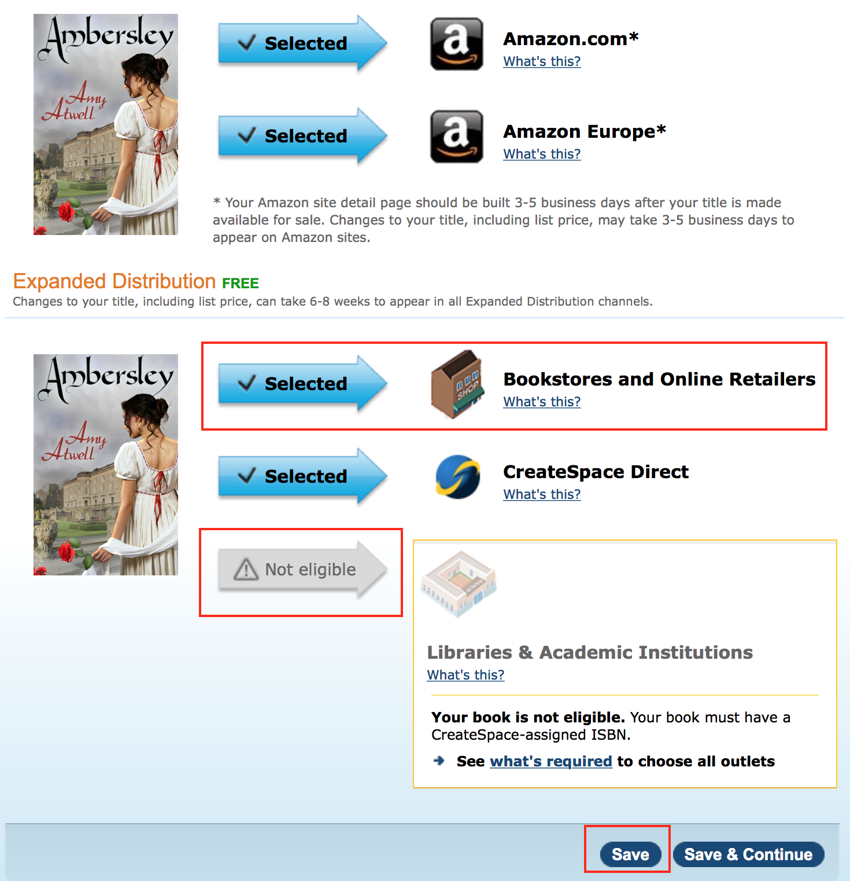
Once you’ve compiled your list, confirmed the books are all actively being distributed to Bookstores, and your IngramSpark dashboard set-up is complete, you are ready to begin the transfer process.

The Transfer Process

Step 1: Download an IngramSpark Global Title Transfer Addendum pdf here:
IngramSpark Global Title Transfer Addendum 2-27-17.pdf

This should download a PDF form to your computer. You can fill in most of the fields on your computer, but the form does require a signature, so you may need to print it out, sign it, then scan it or take a picture of it with your phone so you can attach to an email. You can also fax it to Ingram. You will need your IngramSpark account number from your dashboard. You’ll see it in the upper right corner, right under your name/publisher name, or visit the Account tab to verify all your information for filling in the form).

From IngramSpark Customer Support:
How to complete form: (Please read this to make sure your form is completed correctly. This will help avoid delays. )
- Enter your COMPANY NAME in top line and in bottom client field. Do not enter your name in the fields (unless your name is the name of your publishing company)
- Enter your FULL address in the second line. This includes your zip code.
- Physically sign the form at the bottom of the signature field (or use Adobe's digital e-sign option).
- Enter your IngramSpark account number.
- Enter the current date.
- Do NOT list the ISBNs for transfer on the form.

Step 2: Go back to CreateSpace, and turn OFF the expanded distribution option to Bookstores and Online Retailers. To do this, click to Distribution page for each book you want to transfer, click on the button for Bookstores and Online Retailers to deselect that option, then click the Save button at the bottom. You can leave expanded distribution to CreateSpace Direct as Selected. Note: I know this seems counterintuitive, since I just told you to verify that the Bookstore option was active, and now I’m saying to deactivate it. The book title needs to appear in Ingram’s system, but the distribution has to be discontinued before CS will release it in the transfer.

Step 3. Draft an email to IngramSpark Support to request the transfer. Sample language below. At end of first paragraph, I got in the habit of inserting some basics about pricing for Ingram to follow as they transferred the title. You will want to research and decide whether you want to allow returns on your titles or not, and what discount you want to offer to bookstores/online retailers. You will also be able to edit the pricing after the title has transferred.

SAMPLE:

Send to Email Address: ingramsparksupport@ingramcontent.com

I would like to transfer the following titles from CreateSpace expanded distribution to my IngramSpark account. Below, I’ve attached a signed Title Transfer Addendum form. Expanded Distribution at CreateSpace has been turned off. Covers and interior files are current. For each title, I’ve included the desired USD selling price. Please set up with a 45% discount, no returns. We’ll add foreign currency pricing once titles are established.

Please advise me if any of the below titles/ISBNs do not appear in your system. I can re-activate the CreateSpace expanded distribution temporarily if necessary.

It is my understanding that the $49 setup fee normally charged for setting up a new print title on IngramSpark does not apply to transfers and that there is no transfer or setup fee. If there are any fees directly charged for the transfer, please email me and outline those costs prior to starting the transfer process.

Thank you for your assistance. Please email me if you need any additional information.

LIST: ISBN – Title – Price point

Attach the Title Transfer Addendum PDF to your email.

Step 4: Monitor the Process. You will receive a series of emails from IngramSpark and CreateSpace, as each company confirms that you really want to undertake this process.

IngramSpark should confirm your initial request within 1-2 days. If any of the ISBNs are not showing in their system, they will alert you. Their email to you will contain a Support Request Number. Should you need to reply to them about this transfer, be sure to include that number in correspondence.

CreateSpace will email you after they receive the request from IngramSpark. They will also list a Case # in their email, but it will be a different number than the IngramSpark #. CS will ask you to confirm that you want to transfer the listing of your books to Ingram/LSI (aka, Lightning Source, owned by Ingram). Reply to them to approve moving forward with the transfer.

In a day or two (or 3 or more…) CreateSpace should send you another email, confirming that they’ve had LSI/Ingram transfer the listing for the ISBNs. They usually include a line saying that you can now contact LSI/Ingram to ask them to list the book in your IngramSpark account. To make things more fun, this email will have a Case #, and usually it’s a different number than the email CS sent previously. I think this process either goes through 2 different teams or once they communicate with Ingram, they set up a different Case #.

FWIW, even though CreateSpace says you should contact Ingram, I’ve found that’s not usually necessary. Ingram is monitoring and finishing things up.

In a day or two, IngramSpark should email you a confirmation that your transfer is complete. If there are any outstanding issues or incomplete ISBNs, they’ll tell you in the email.

Step 5: Log into your IngramSpark dashboard and review each title. I’ve found that the description sometimes loses all formatting and just becomes words that run together. There’s a little edit button you can click, and they’ve got a pretty nice HTML editor so you can make the description prettier. Also review:
- Imprint Name (it will show your dashboard legal name, I believe, and you can request a second imprint name via the dashboard if you want something different to show)
- Pricing to add prices for foreign currencies and review the returnability and discount settings

The overall process can take as little as four days. Or… it may take four weeks. Of the two teams, the IngramSpark staff is more reliable. It can be a little hit or miss with the CreateSpace team. I’ve included some troubleshooting tips on the next page.

BIG CAVEATS ABOUT FUTURE UPLOADING OF NEW TITLES AT INGRAM:

I have no idea how easy or whether it will be possible to transfer paperback titles from the KDP dashboard’s expanded distribution to IngramSpark. Logic says it should be a similar process, but I haven’t had a chance to try it.

For future books, if you want to upload them directly to IngramSpark, they do offer the advantage of preorder for print books. You can also upload new books to IngramSpark using the same ISBN you use to upload to KDP in future, as long as you don’t activate the expanded distribution to bookstores and online retailers at KDP.

When uploading new print books to IngramSpark, there’s a $49 setup fee. You can often find coupon codes to waive that fee. I uploaded a book on August 30, and used GETPUBLISHED as the coupon code, and that worked. Not sure whether it will continue to work through September. NINC and ALLi both have conferences coming up, and Ingram often runs promos with both groups.

IngramSpark will accept the same dimensions for both cover and interior files that CreateSpace/KDP accepts. Meaning, the same cover art dimensions that work at CS/KDP should also work if uploaded directly to IngramSpark. CAVEAT: IngramSpark will give you processing errors on the interior PDF and/or cover PDF if either contains RGB colors or ICC color profiles. CS/KDP are much more forgiving about these.

If you upload and receive an error, there is usually an option to have Ingram override the color issues. Bearing in mind that every book you transferred from CreateSpace to IngramSpark probably had these same errors and IngramSpark overcame them, it should be safe to allow them to do this. But I always recommend ordering a print proof to see what it looks like.

Troubleshooting:

IngramSpark replied to say that one or more of my transfer ISBNs are not showing in their system. What do I do?

You can ask them to proceed to transfer all the active ISBNs. Meanwhile, go back to CreateSpace and find the problem ISBN and activate it again for Bookstore and Online Retailer distribution. Email IngramSpark (using same Support Request #) and tell them you’ve re-activated the ISBN for distribution via CS. They will email you when they see it in their system. Once they’ve emailed you, go back to CreateSpace and take the book OFF distribution for Bookstores so Ingram can complete the transfer. No need to resend a new Addendum form.

CreateSpace sent me an email and it looks like I’m supposed to contact LSI at cssupport@ingramcontent.com to complete my transfer. Should I?

No. The cssupport email is Ingram’s support account specifically for CreateSpace. You should always communicate with IngramSpark using your Support Request # at ingramsparksupport@ingramcontent.com.

CreateSpace sent me a forwarded email that appears to have come from lscamazoncustomersupport@lsccom.com and they claim they don’t have my book files. What should I do?

First, take a deep breath. This means that CreateSpace accidentally emailed the printing company that handles the printing of books, LSC Communications instead of Lightning Source/Ingram. Reply to the CreateSpace team and politely tell them you’re seeking to transfer your titles to IngramSpark, and on their end, you believe they should be communicating with cssupport@ingramcontent.com instead of the LSC Communications people.

I’m on IngramSpark now, and I want to edit my pricing, but the dashboard doesn’t seem to want to let me edit. What should I do?

First off, congrats on a successful transfer! If the pricing fields in the dashboard won’t allow you to edit, chances are that it’s near the end of a calendar month. Say, after the 24th of the month, and there’s a field at the top of the pricing matrix that says you want your changes to go live on the 1st of the next month. Ingram Spark updates print pricing monthly, at some point during the last 5 or so days of the month. You can push your date to the 1st of the following month (so, it’s September now, if you have problems near the end of September, tell Ingram you want changes to go live on Nov. 1 instead of Oct. 1) and all the pricing fields should become active again.

Questions? Email me. Not positive I can answer everything, but chances are good…

